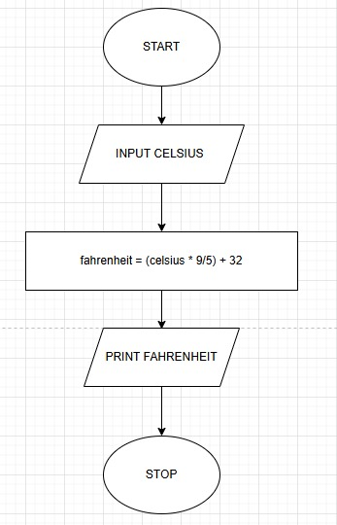
ALGORITHM
Step 1:- Start
Step 2 ;- Read temperature in Celsius as float value Celsius
Step 3:- Calculate Fahrenheit using formula:
$$fahrenheit=(celsius×\frac{9}{5})+32$$
Step 4 :- Print the Fahrenheit value formatted to 2 decimal places
Step5:- Stop

3.1.2. Celsius to Fahrenheit

